CharityComms eNews advertising policy

CharityComms circulate an e-newsletter to almost 10,000 subscribers once a fortnight. These subscribers are made up of a mix of organisational and individual members, corporate partners, and sector peers who follow our work but are not yet members.

Given the makeup of our e-newsletter recipients it is important that anything we promote to them is in line with our organisational values. As part of this and in the spirit of full transparency, all adverts will be marked up as a ‘Sponsored ad’ and will have to meet the following requirements:

- Adverts taken out in CC’s eNews should be offering something of value to our community eg. A discount, a free guide, white paper etc.
- However, in recognition of the fact that the services corporate partners offer our members are of value to sector work, we will also consider a maximum of one standard business service ad per year per corporate partner that does not necessarily need to follow the guidelines in point 1. In this instance we do not guarantee that it will be the only advert run in that edition of the mailout (there could also be either an ad paid for by another corporate partner, or one that is included as part of a corporate sponsorship package running at the same time).
- Adverts must comply with standard specifications, set out below, and be provided to CC for approval by the Friday before the ad is due to run.
- If we receive multiple requests for adverts in the same week priority will be given to those that ad value as stated in point 1, after which we will accept standard business service ads on a first come first served basis.
- Payment for the advert must be made within two weeks of publication.
- CC reserve the right to decline any advert that we feel does not meet the requirements and/or to suggest appropriate amendments.

Standard ad specifications:

- Length: 50 words
- Image: a copyright free jpg image of 400 x 300 px must be provided
- Links: inclusion of one hyperlink

Ad costs:
- Non-members: £350+vat
- Members: discounted price of £300+vat per edition of eNews

Example ad below:
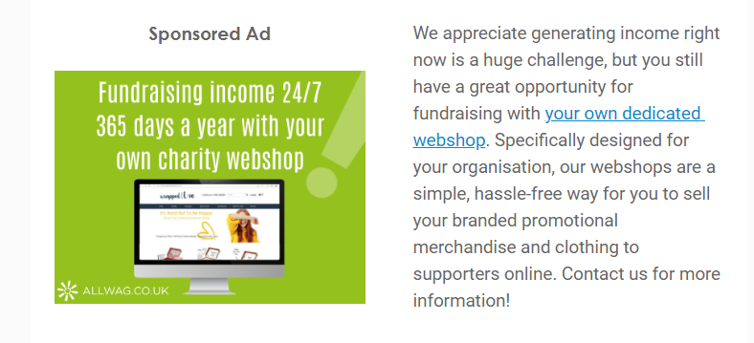

To book an ad slot, or if you have any questions please contact our head of digital content Christine Fleming via email: christine@charitycomms.org.uk

