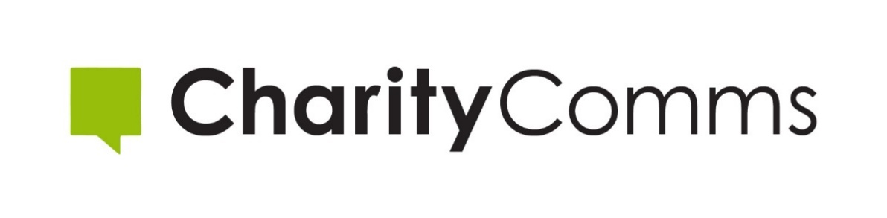

CHARITYCOMMS STRATEGY 2020 -2023
CharityComms is the membership network for communications professionals working in UK charities and not for profits.
We’re here to help raise the standards of communications across the sector, to fly the flag for communications as a vital strategic function at the heart of charities, and to connect communications professionals through sharing best practice.

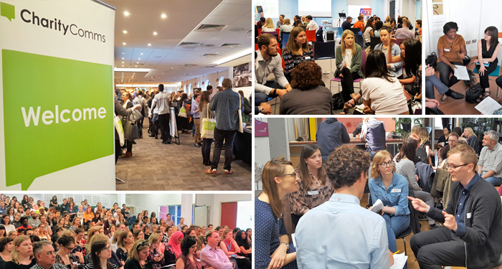

“A force for good within the charity sector, helping to bring people and ideas together.” - CharityComms member quote (2019-2020 survey).

Where we have come from

CharityComms experienced strong growth and impact from 2016 to 2019:
- With overall membership numbers growing by 14%.
- Organisational income growing by 45%.
- We have over 750 organisational members, 100 corporate members and 400 individual members.
- Our network includes more than 8000 people.
- We have over 44,600 followers on Twitter.
- Membership retention rates have risen to 93%.
- Perceived value among members is robust, mainly built around the strong and extensive events programme and the value attached to the unique network and community CharityComms has nurtured.
- In 2018/19 over 4,500 people attended our 67 events.
- Last year our Digital Benchmark participants grew by 31% to 71 charities.
- 95% of attendees said they had gained new knowledge and enhanced skills and 91% said they would try something new.
- Last year we made 197 mentor matches (more than three times the previous year).

But there is still much to do
Charity communicators are on the frontline, helping charities steer their way through a volatile, and complex world. Fragile public trust, rapidly changing technology, shifting demographics and political uncertainty have made the need for outstanding communications even more vital.
This strategy is built around the knowledge that the UK is facing tough economic times and that this in turn will put charities under pressure. The money and time charities and our partners have to invest with CharityComms is at risk.
This is why our focus is on membership, maximizing our assets and working smarter - increasing the value and impact of membership, using technology to increase efficiency, providing greater access to resources and ensuring business sustainability.

Some feedback from our membership survey on what members would like to see more of, or for us to introduce includes:

- 67% of respondents said they would like additional workshops.
- 57% said they would like to see us produce webinars for easier access.
- 52% said they would like an online community area.
- “Being able to login as a member [e.g. an online area for members].”
- “More dedicated courses and seminars for leaders.”
- “Specific benefits/support tailored to freelancers.”
- “Transparency / equal access to speaking opportunities.”
- “More events outside of London.”
- “Campaigning on the value of communications within charities and raising awareness and building support among execs. “

Our vision: we enable every charity to value and use effective communications for a better world.
Our purpose: We champion the value of communications and continually improve the quality of communications by connecting and inspiring our community.
Our values:
Championing – We’re ambitious leaders. We champion the value and impact of charity communications and your professional role in the sector.
Inspirational – We’re enthusiastic forward-thinkers. We seek out new ideas and best practice and share widely with our members.
Welcoming - We’re a warm and helpful bunch. We’re on your side.
Community – This is a place where you belong. We create a supportive, inclusive community and special interest groups within it.

Our sector specific goals to be achieved by the end of 2023:
Communications will be recognised across the sector as an integral part of the effectiveness of charities. | Charities will have SMT/senior board representation from communications (i.e. an equal voice at the top table).
More and better resources will be available to help charity communicators improve their skills and the impact of their work. | The planning and delivery of charities’ communications is aligned with their brand and organisational strategy.

Goals for CharityComms:
- All Charity communicators will be aware of and have access to the benefits and services offered by CharityComms.
- We will substantially improve the baseline skills and competencies of individuals at all levels with the sector through our products and services.
- It will be standard practice to become a member of CharityComms as an indicator of your commitment to communications and your professional development.
- We will be seen as the hub for innovation, best practice and thought- leadership and can demonstrate the impact this has.
- Where appropriate, we will use our research, knowledge and networks to contribute to a better operating environment for our members, and a more resilient charity sector.

Our approach:
Our membership community is our greatest asset and remains a fortress of goodwill, idealism and pragmatism in equal measure. There is a willingness and desire to share good practice, and a rising acknowledgement that we are in it together, and interconnected through our sector, reputations, and comms profession.
It is this network of comms professionals, that includes corporates, organisations and individuals, that CharityComms has nurtured, winning trust and gaining credibility along the way. In bringing these groups together under a membership umbrella, we not only service their needs, but continue to benefit from the knowledge, experience, and skills that they are willing to share for their own and the greater good.
Putting the community front and centre continues to be the defining model for CharityComms and shapes the choices and priorities in the strategy.

Improving – we will…
- Improve internal systems to ensure efficiency and the best possible audience experience.
- Phase out time-consuming manual processes to speed up response and free up staff time.
- Invest in continuous staff and trustee learning and development.
- Develop a diverse and inclusive culture where staff, trustees and our community feel welcome, valued and able to thrive.

Maximising – we will…
- Make the most of our unique high-quality content.
- Create tailored marketing plans and integrated member journeys and help track learning and development year on year.
- Be responsive to member preferences – providing content in the right place, at the right time, frequency and channel.
- Look for multiple ways to listen, understand and respond to member needs.
- Clarify and enhance exclusive member benefits - strengthening the case for support and the value of being part of the CharityComms community.
- Grow membership to increase diversity and inclusion and engage new sectors and markets.

Partnering – we will…
- Form strategic partnerships with other sector bodies, agencies and thought leaders.
- Build capacity – to increase profile, reach and impact.
- Diversify our portfolio and provide access to a wider range of expertise.
- Play to our strengths and avoid duplicating effort.

Championing – we will…
- Champion best practice communications to influencers, policy makers and the media.
- Reach, influence and empower C-suite audiences to invest in and ensure strategic communications sits at the heart of what they do (Chairs, CEOs, Directors of communications).
- Help charities navigate sector challenges – from building strong and resilient brands, dealing with PR crisis, building public trust, and becoming a more diverse and inclusive sector.
- Use data more effectively to monitor and evaluate our own performance at CharityComms and share that insight with stakeholders.
- Develop tools which help charities gather evidence of the value and impact of strategic communications to support the case for investment to trustees and senior teams.
- Find ways to tackle the impact of communications on the climate.

Membership survey 2019/20 - member quotes:
“The CharityComms staff are always very friendly and welcoming (in person and on email), it feels more like a community, the events are engaging and not pretentious but educational. The UK wide sector groups are really important I think too. As are all the practical guides/reports etc. - it's hugely contributed to my role and how I do comms.”
“Having the opportunity to talk to other people in the sector - and the fact that everyone is so willing to share their experiences with one another. Great atmosphere at all CC events.”
“The conferences are great. I love how particularly in recent years, CharityComms really feels like it champions the sector, promotes good stuff and celebrates what we do. Also, I think the mentoring has been instrumental in my career development.”
“The conferences/other events - they are always far more insightful than any other events I've attended as they are targeted at both the professional sector, e.g., comms/digi and on top of that, they are charity focused which really makes a huge difference to the amount of insights and ideas you come away with.”
“A good range of events and seminars, suited to different roles within our department.”
“The Wales events are brilliant, well done to the team there.”
We are adopting a phased approach over the 3 years of the strategy:
IMPROVING  We'll improve our systems and invest in developing our staff and trustees to provide the best service for our members | Priority: Years 1-2
MAXIMISING  We'll make the most of our unique quality content - marketing, sharing, and increasing access to resources | Priority: Years 1-2
PARTNERING  We'll work collaboratively with others to extend reach and impact | Priority: Years 2&3
CHAMPIONING  We'll gather and promote evidence of the effectiveness and impact of communications | Priority: Years 2&3

